Design Patterns in Java – Complete Tutorial with Code
This tutorial covers:
- ✅ What design patterns are
- ✅ Creational, Structural, Behavioral categories
- ✅ Real-world scenarios
- ✅ Java code examples
- ✅ Best practices

1️⃣ What Are Design Patterns?
Design patterns are proven solutions to common software design problems.
They:
- Improve code structure
- Promote reusability
- Reduce coupling
- Increase maintainability

2️⃣ Design Pattern Categories

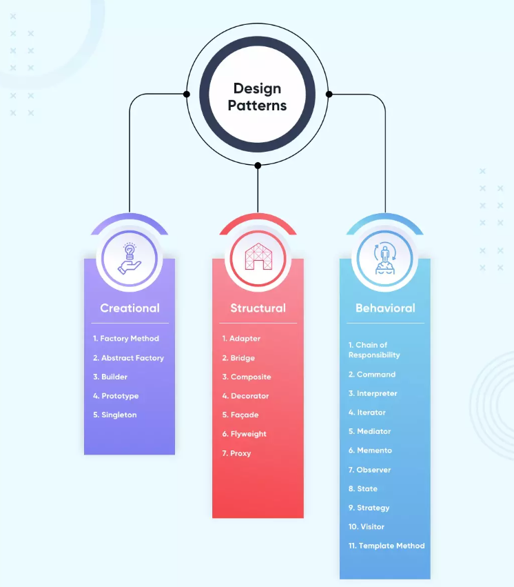
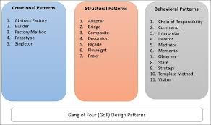
4
Category | Purpose
Creational | Object creation
Structural | Class/object composition
Behavioral | Communication between objects

🏗 3️⃣ Creational Patterns
Focus: How objects are created

3.1 Singleton Pattern
Ensure only one instance exists.

Real Scenario:
Database connection manager

Code Example
class DatabaseConnection {

private static DatabaseConnection instance;

private DatabaseConnection() {}

public static DatabaseConnection getInstance() {
if (instance == null) {
instance = new DatabaseConnection();
}
return instance;
}
}

Best Practice (Thread-safe version)
class DatabaseConnection {

private static final DatabaseConnection instance =
new DatabaseConnection();

private DatabaseConnection() {}

public static DatabaseConnection getInstance() {
return instance;
}
}

3.2 Factory Pattern
Create objects without exposing creation logic.

Real Scenario:
Payment processing system

Code Example
interface Payment {
void pay();
}

class CreditCardPayment implements Payment {
public void pay() {
System.out.println("Paid using Credit Card");
}
}

class UpiPayment implements Payment {
public void pay() {
System.out.println("Paid using UPI");
}
}

class PaymentFactory {

public static Payment createPayment(String type) {

if (type.equals("CARD"))
return new CreditCardPayment();
else if (type.equals("UPI"))
return new UpiPayment();

throw new IllegalArgumentException("Invalid type");
}
}

3.3 Builder Pattern
Used for complex object creation.

Real Scenario:
Building a user profile with optional fields

class User {

private String name;
private int age;
private String email;

private User(UserBuilder builder) {
this.name = builder.name;
this.age = builder.age;
this.email = builder.email;
}

public static class UserBuilder {
private String name;
private int age;
private String email;

public UserBuilder(String name) {
this.name = name;
}

public UserBuilder age(int age) {
this.age = age;
return this;
}

public UserBuilder email(String email) {
this.email = email;
return this;
}

public User build() {
return new User(this);
}
}
}
Usage:
User user = new User.UserBuilder("Amit")
.age(25)
.email("amit@gmail.com")
.build();

🧩 4️⃣ Structural Patterns
Focus: How classes and objects are structured

4.1 Adapter Pattern
Convert one interface into another.

Real Scenario:
Old payment API integrated into new system.

class OldPaymentSystem {
public void makePayment() {
System.out.println("Old system payment");
}
}

interface NewPayment {
void pay();
}

class PaymentAdapter implements NewPayment {

private OldPaymentSystem oldSystem;

public PaymentAdapter(OldPaymentSystem oldSystem) {
this.oldSystem = oldSystem;
}

public void pay() {
oldSystem.makePayment();
}
}

4.2 Decorator Pattern
Add behavior dynamically.

Real Scenario:
Coffee with add-ons

interface Coffee {
double cost();
}

class SimpleCoffee implements Coffee {
public double cost() {
return 100;
}
}

class MilkDecorator implements Coffee {

private Coffee coffee;

public MilkDecorator(Coffee coffee) {
this.coffee = coffee;
}

public double cost() {
return coffee.cost() + 20;
}
}
Usage:
Coffee coffee = new MilkDecorator(new SimpleCoffee());
System.out.println(coffee.cost());

🔁 5️⃣ Behavioral Patterns
Focus: How objects communicate

5.1 Strategy Pattern
Choose algorithm at runtime.

Real Scenario:
Sorting options in app

interface SortingStrategy {
void sort();
}

class QuickSort implements SortingStrategy {
public void sort() {
System.out.println("Quick sort used");
}
}

class BubbleSort implements SortingStrategy {
public void sort() {
System.out.println("Bubble sort used");
}
}

class SortContext {

private SortingStrategy strategy;

public SortContext(SortingStrategy strategy) {
this.strategy = strategy;
}

public void execute() {
strategy.sort();
}
}

5.2 Observer Pattern
Notify multiple objects when state changes.

Real Scenario:
Stock price notification

interface Observer {
void update(String message);
}

class User implements Observer {
public void update(String message) {
System.out.println("Notification: " + message);
}
}

class Stock {

private List<Observer> observers = new ArrayList<>();

public void addObserver(Observer observer) {
observers.add(observer);
}

public void notifyObservers(String message) {
for (Observer o : observers)
o.update(message);
}
}

🎯 Applying Patterns in Real Projects
Scenario | Pattern
Logging service | Singleton
Payment gateway | Factory
Config builder | Builder
UI customization | Decorator
Multiple algorithms | Strategy
Event notification | Observer

🏆 Best Practices
✔ Don’t overuse patterns
✔ Use patterns to reduce coupling
✔ Prefer composition over inheritance
✔ Follow SOLID principles
✔ Keep implementation simple

🧠 Interview-Level Understanding
Design patterns:
- Improve architecture
- Increase flexibility
- Make code easier to maintain
- Solve recurring design problems

🔥 Quick Summary
Category | Example
Creational | Singleton, Factory, Builder
Structural | Adapter, Decorator
Behavioral | Strategy, Observer

